Raspbot connects to WiFi

1. Enter the Raspberry Pi desktop (you can connect to the hotspot of the car and use this (ip: 10.42.0.1) to connect to VNC, SSH, or enter the Raspberry Pi system by connecting to the screen via a screen cable)
2. Graphical interface

Using the Raspberry Pi graphical desktop system, we can connect to the corresponding WiFi by clicking on the network icon in the upper right corner of the menu bar  
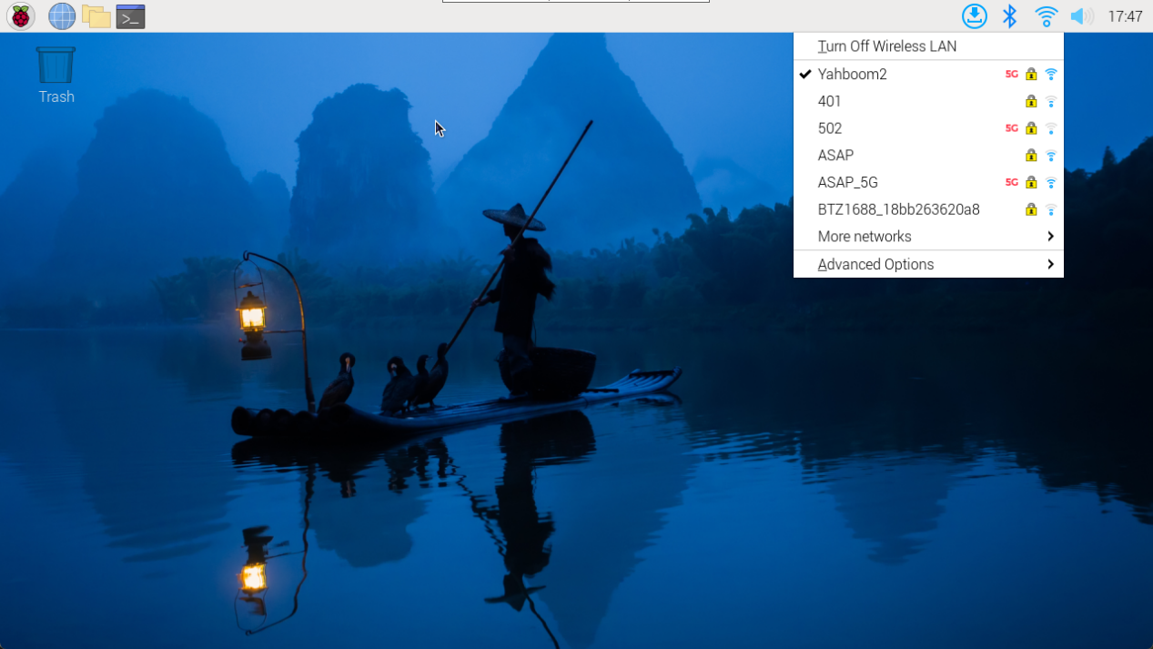  
```

Note: If no region is set, the first time you connect to the network, you need to set the region before network configuration can be performed.  
The mirror image of the car can be omitted from this step

```

1. Command line

For systems with non graphical interfaces, the network can be configured through the command line. (SSH login method)

```

Note: You need to first use the raspi configuration tool to set the WLAN country/region, and then use the command line to configure the network.

```

USing raspi-config tools：Terminal input sudo raspi-config

Set up WLAN country/region：

Localisation Options → WLAN Country → CN China → OK

After completing the above option settings，choice FinishExit the raspi-config tool.

- View WiFi enable status command：nmcli radio wifi

- Enable WiFi status command：nmcli radio wifi on

- Turn off WiFi status command：nmcli radio wifi off

- Find network commands：sudo nmcli dev wifi list

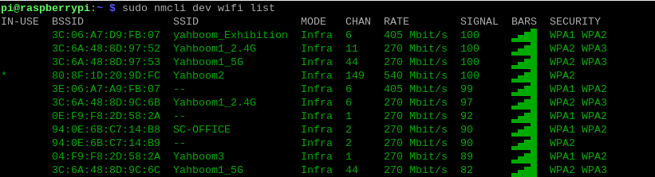  
Connect Network Command：sudo nmcli --ask dev wifi connect <example_ssid>  
image-20231218175715842  
```

Note: If there is no permission to operate, please add sudo before all commands

```

The above message prompts that the WiFi connection is successful!

Rsapbot hotspot/WiFi Self start upon startup

We can set the Raspberry Pi system to power on and connect to WIFI or turn on hotspots by modifying the priority of network settings according to our own needs.

```

Priority number is high, choose this connection method first!

```

